# Lab: REST Services and AJAX

Problems for in-class lab for the "[JavaScript Applications" course @ SoftUni](https://softuni.bg/opencourses/js-apps).

**1. REST Countries**

**NOTE: Install** "[Postman](https://www.getpostman.com/)" REST Client to **ease** your tasks.

Your first task is to get detailed information about Bulgaria.

* Send a "**GET**" request to the link given below.
* **Copy** the response in JSON format.

**REQUEST**:

<https://restcountries.eu/rest/v2/name/Bulgaria>

Screenshot_442.png

**RESPONSE**:

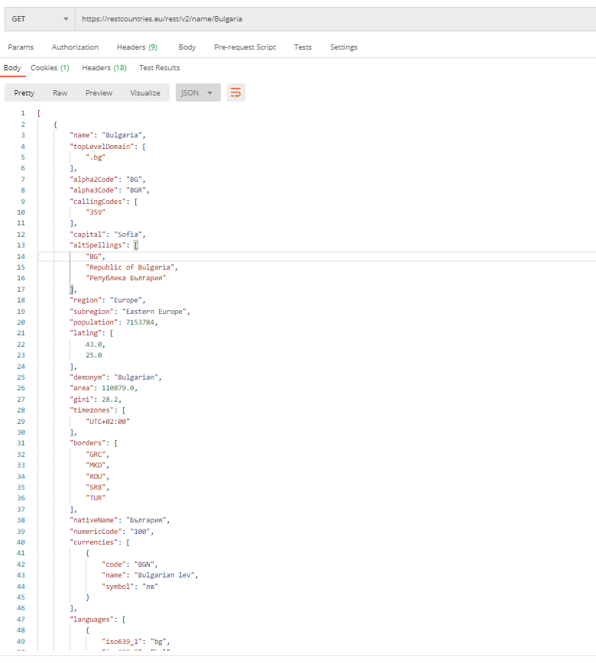

**2. GitHub: Labels Issue**

Get the **first** issue from repository with **name** “test-nakov-repo”. Send a GET request to https://api.github.com/repos/testnakov/test-nakov-repo/issues/:id, where :id is the issue.

**3. Github: Create Issue**

This time we have to **create** an issue (data should be **send** to the server). Send a "**POST**" request to the server with the following JSON as **body** (send it as application/json):

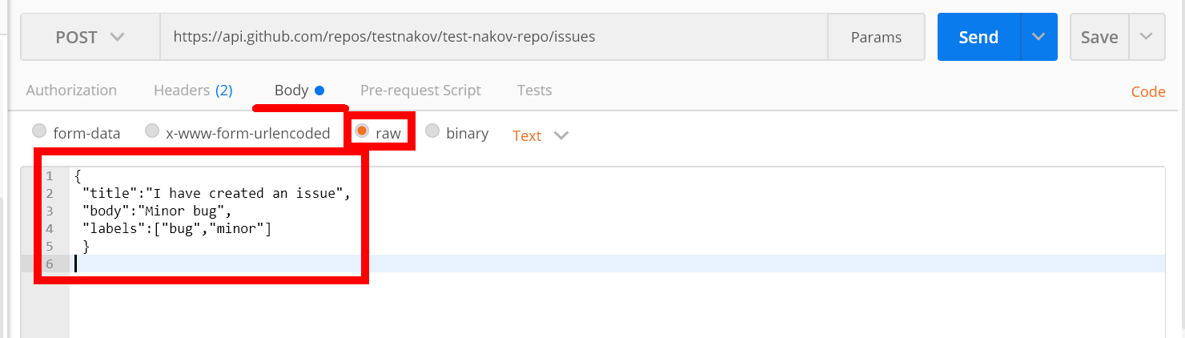

You need to use your GitHub **account credentials** to submit issues. Under the Authorization tab, select Basic and enter your username and password. Send the request to the URI from the previous task, but without the :id.